**Seaford School District**

**Department of Nutrition Services**

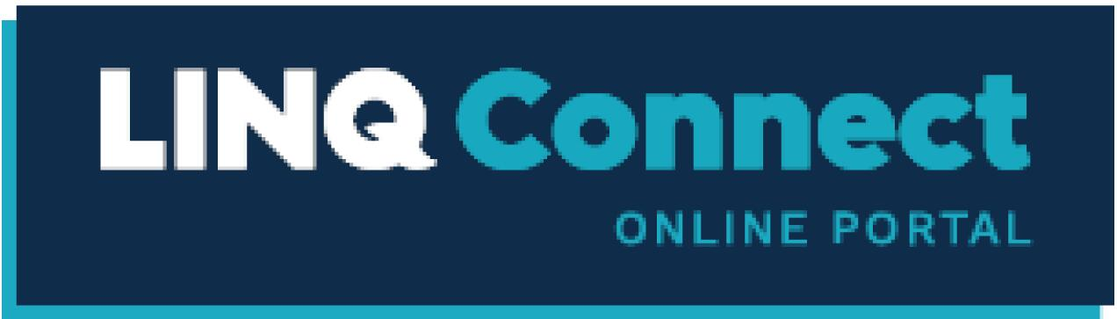

**It is a secure online system that allows parents to:**

- Make an online payment to your children's cafeteria meal bills

- Remotely monitor your children's accounts

- Set up automatic recurring payments

- Set up alerts for low balance emails

**How do you get started? Getting started is as easy as 1, 2, 3.**

**1. Sign Up**

Sign up for [https://linqconnect.com](https://linqconnect.com/) by clicking **Sign Up Today!**

**Required information: student's first and last name and date of birth.**

**2. Confirm Email**

Confirm your email address by clicking on the email verification link sent to your email address.

**3. Log in**

You can now log in [to https://linqconnect.com](https://linqconnect.com/) with your email and password.